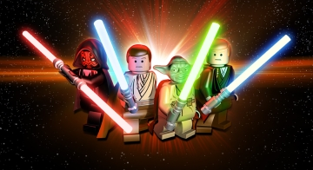

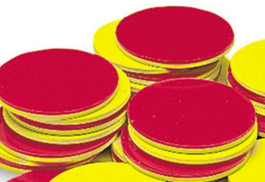

**To make your own Straw wars game you will need:**

Plastic cup to hold straws: I used Solo cups

A bunch of straws cut in different lengths

Either a token to flip or a coin to toss; red side faces up(heads): longest straw wins . Yellow side (tails) shortest straw wins.

How **to play: (two or more players can play)**

Each player choses one straw, then you compare the lengths of the straws. Discuss whose is longer/shorter. Then flip the token or coin. The one that has the winning toss keeps both straws. Keep playing it till there are no more straws in the cup. Then each player lines up the straws they won and create a line, then flip the token or coin one last time to see who gets all the straws,



**Tower Grab:** We used a paper bag and unifix cubes and the red and yellow token, You can use a coin, as you did in Straw Wars:

